Beauty Care

*Developer Guide*

|  |  |  |
| --- | --- | --- |
| **Supervisor.** | **Sir Ebad Uddin** | |
| **Batch.** | **2211B1** | |
| **Group.** | C | |
| **Serial No.** | **Enrollment Number** | **Student Name** |
| 1. | 1430118 | Muhammad Yahya Kaka |
| 2. | 1431148 | Muhammad Umar |

**1.Home** (*index.html*)

**Figure 1: Home page to Beauty Care**

 Our website attracts girls by offering them the best product with awesome prices.

* Our homepage invites our customers with a great product for their beautiful skins.

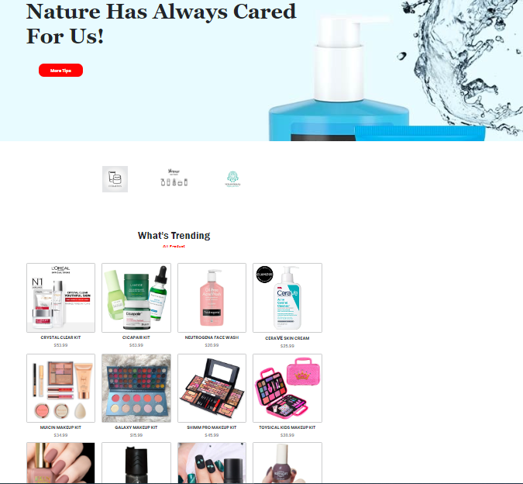

*Code Of Home Page*

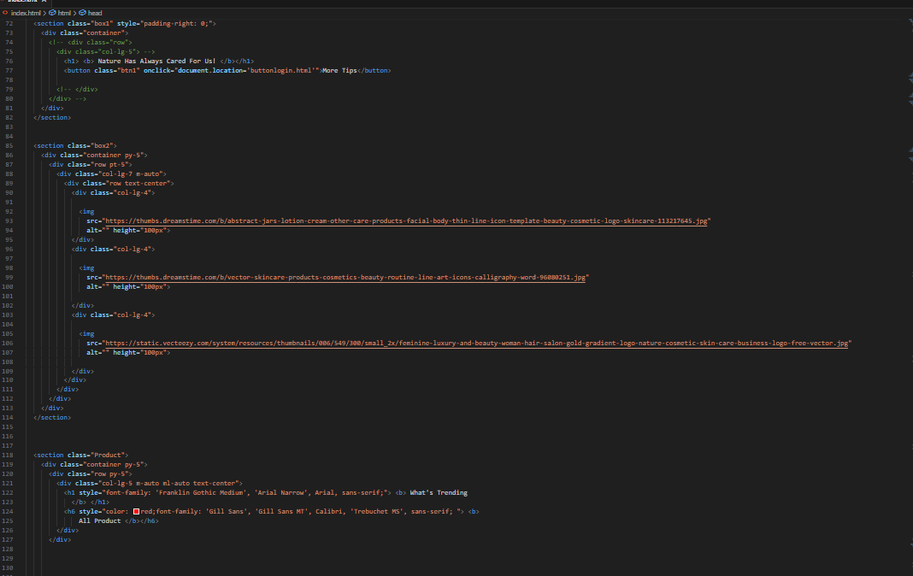

**2.Navbar (index.html)**

We have given FIVE essentials. By clicking any of the essentials you will be redirected to the linked page. (Index.html)

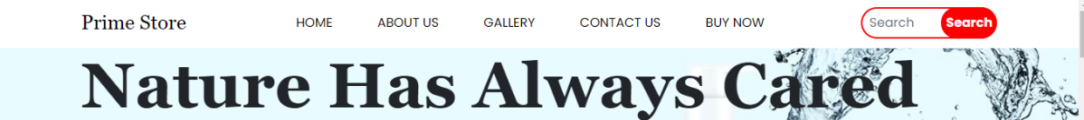

***Figure 2: Navbar***

*Code Of Navbar*

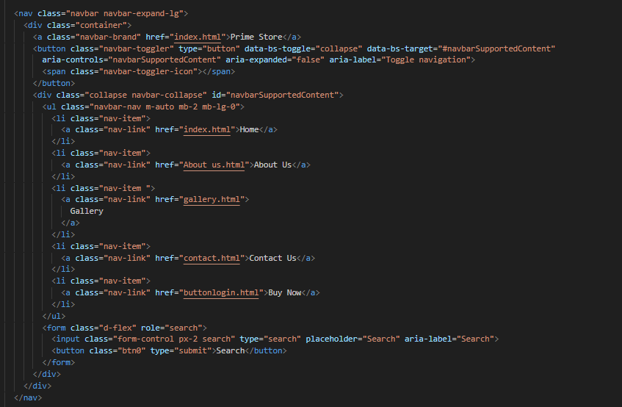

**3.Product(index.html)**

* We recommend the best product.
* A user can find a product consisting.
* All the recommended product contains their goods ratings to give the user authentic reviews.

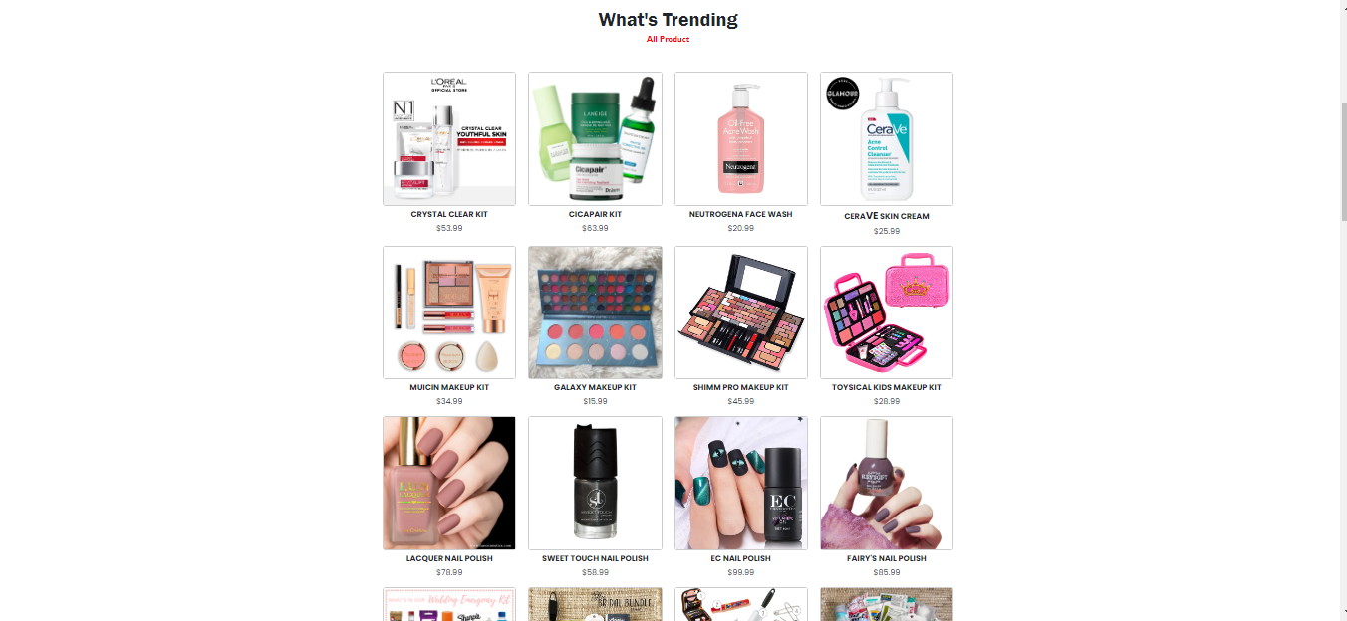

***Figure 3: PRODUCT***

*Code Of product*

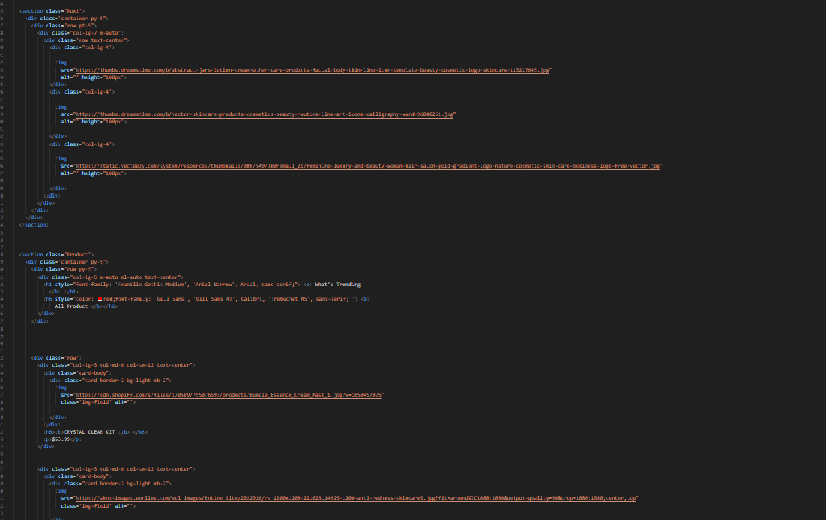

**4.Gallery(gallery.html)**

*We have given some of the most beautiful product of our product we recommend to our users for a better understanding.*

* ***Here we display some images of the product we recommend.***

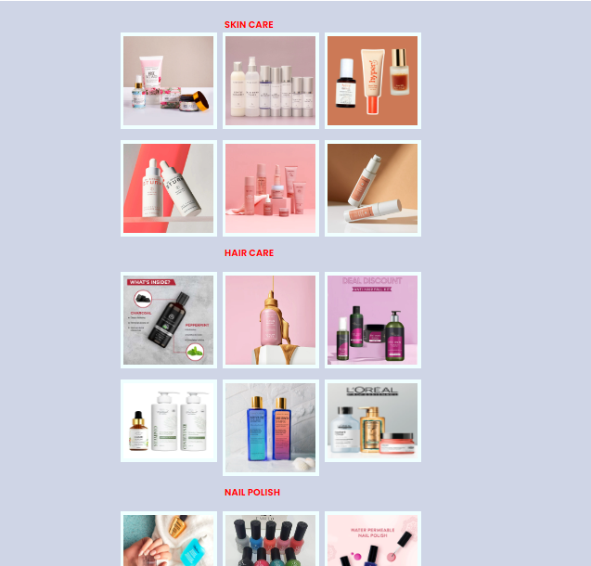

***Figure 4: Gallery***

*Code Of Gallery*

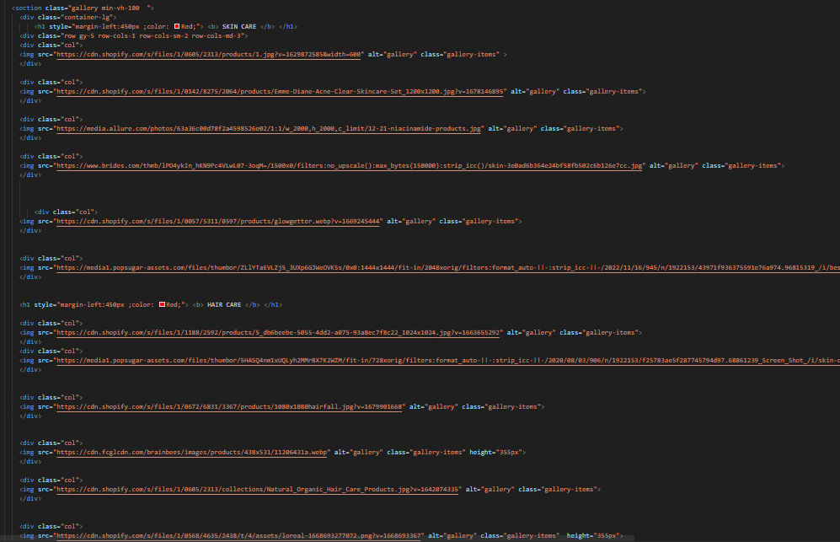

***5.About Us (about.html)***

***“Description about our website”***

*We have given the user some information about our website.*

* ***Information about our website***

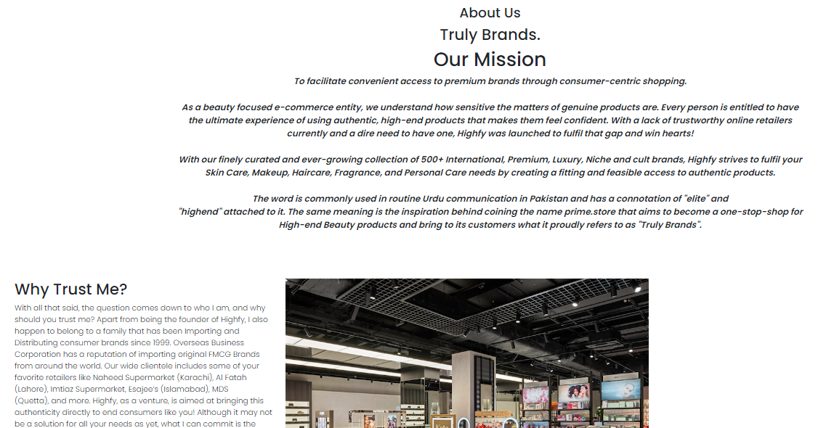

***Figure 5: About us***

*Code Of About Us*

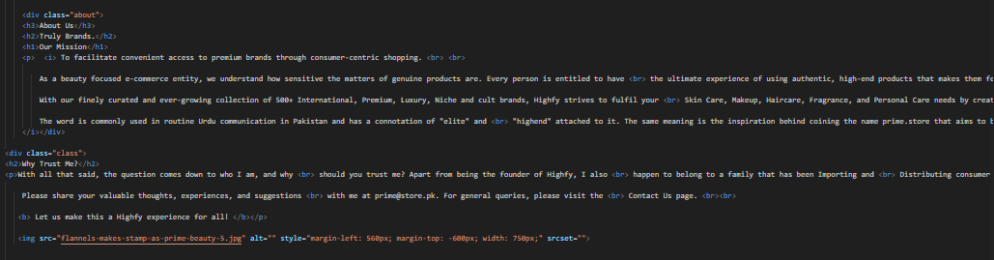

***6.Contact Us (contact.html)***

*We have given the user information to contact us, leave reviews and send queries.*

* ***Information to contact us has been displayed on this page.***
* ***Our address has been displayed with our phone number.***
* ***A query message box has been displayed under the information with which the user can ask us any questions they require answers to***
* ***Review box has been displayed at the end of the page to get the satisfaction of our user.***

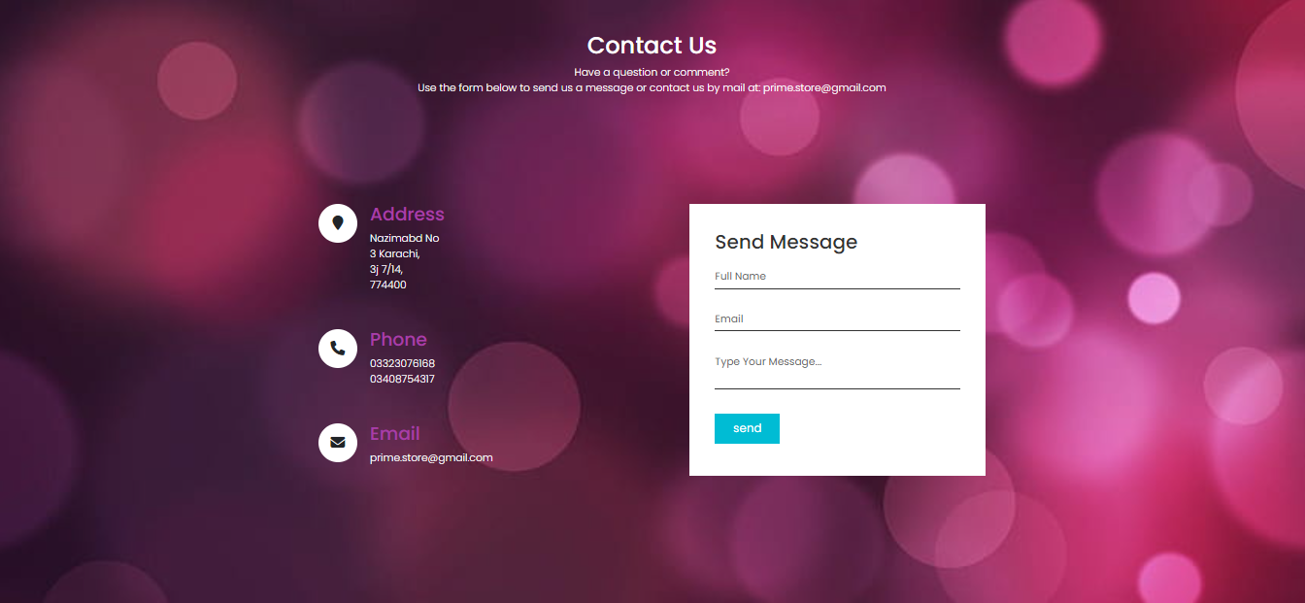

***Figure 6 : Contact us***

*Code Of Contact Us*

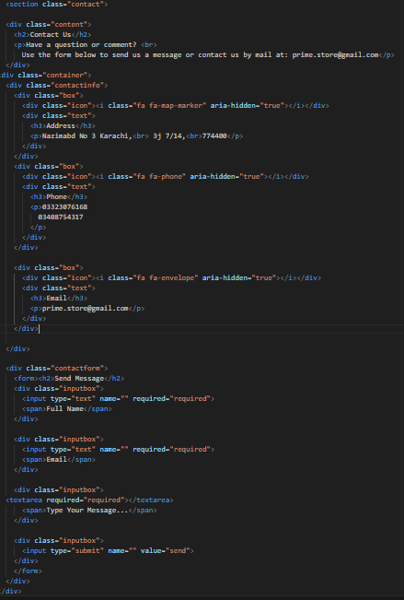

***7. Login(login.html):***

*It is a necessity to sign up and login afterwards to get a look at our website after successfully logging in the user will be redirecting to our homepage and then can navigate all over the website.*

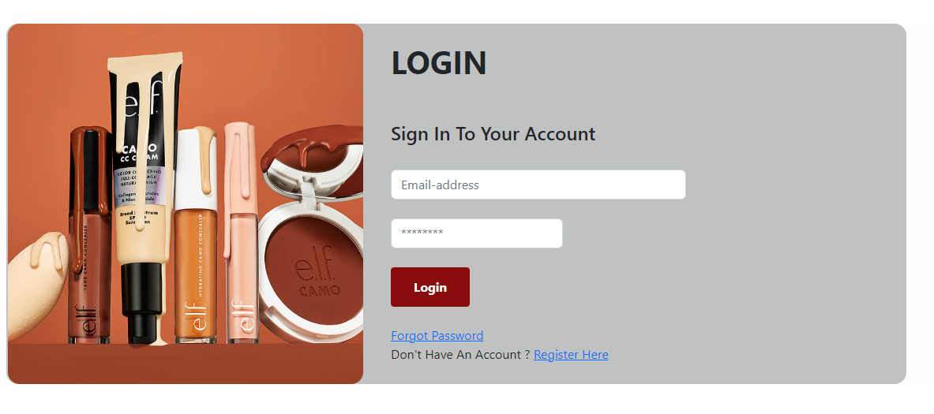

***Figure 6: Login***

*Code Of Login*

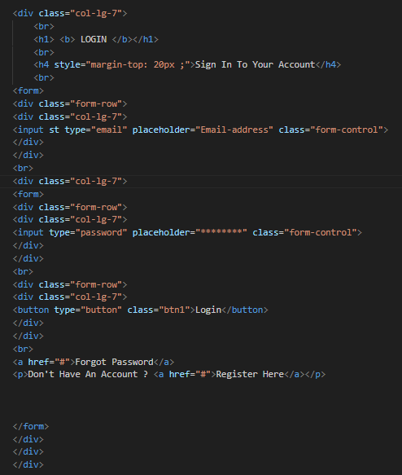

***8. signup(signup.html):***

*The user needs to sign up to login and navigate through our website as they like.*

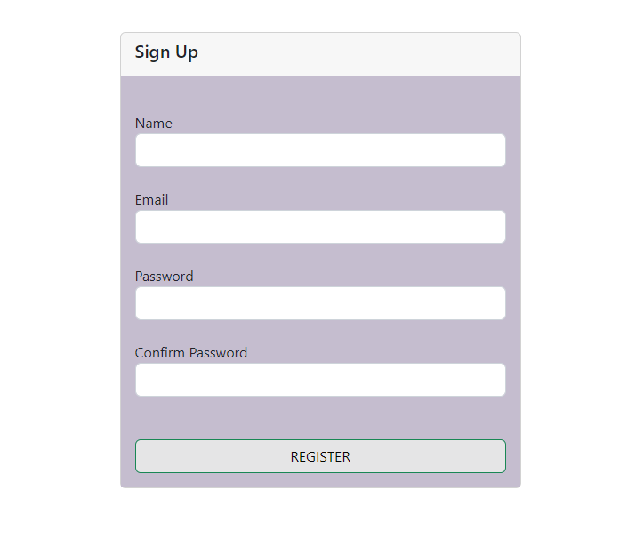

***Figure 8: Signup***

*Code Of Signup*

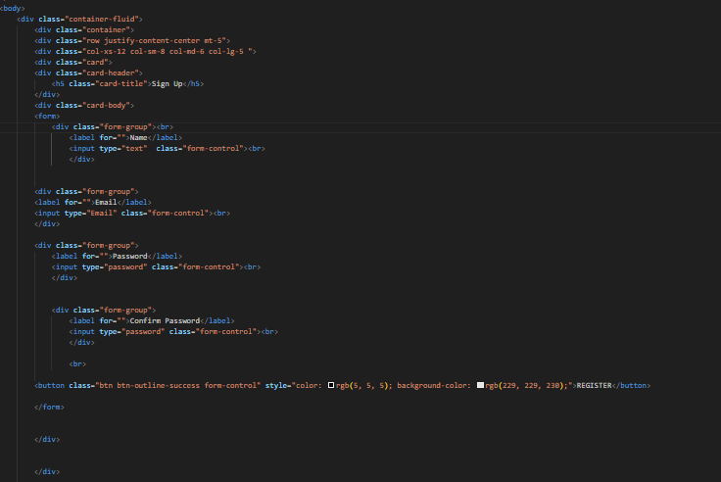

***9.Footer (index .html):***

*We have given some links in the footer which will redirect u to social media platforms and we have added hover affects for a more prominent look.*

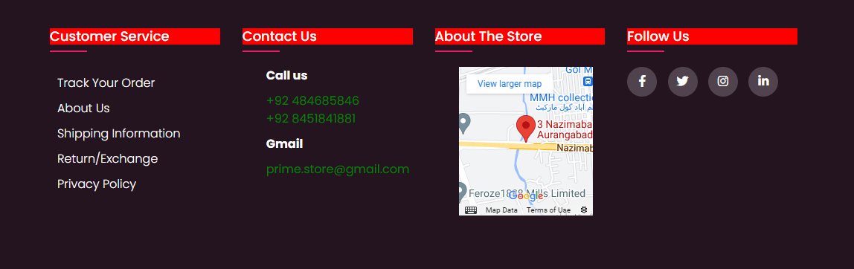

***Figure 9: Footer***

*Code Of Footer*

